SUPPLEMENTARY MATERIAL

NPI dates information

Region and intervention | Wales CP1 | Wales CP2 | Scotland CP1 | Northern Ireland CP1 | England CP1
Intervention date | 2021/10/11 | 2021/11/15 | 2021/10/18 | 2021/11/29 | 2021/12/15
Restrictions imposed | Covid passports – including either vaccination status or a negative Covid test within the past 48 hours – have also been required to attend nightclubs, unseated indoor events with over 500 people, unseated outdoor events with over 4,000 people, and any event with over 10,000 people. | Extended to cinemas, theatres and concert halls. | Covid passports have been required to attend nightclubs, unseated indoor events with over 500 people, unseated outdoor events with over 4,000 people, and any event with over 10,000 people. | The pass would be mandatory in the same venues as Wales and also pubs and restaurants. | Covid pass will now be mandatory for nightclubs, unseated indoor events with 500 or more attendees, unseated outdoor events with 4,000 or more attendees and any event with 10,000 or more attendees.

Plots for the Negative Binomial Segmented Regression models

Northern Ireland

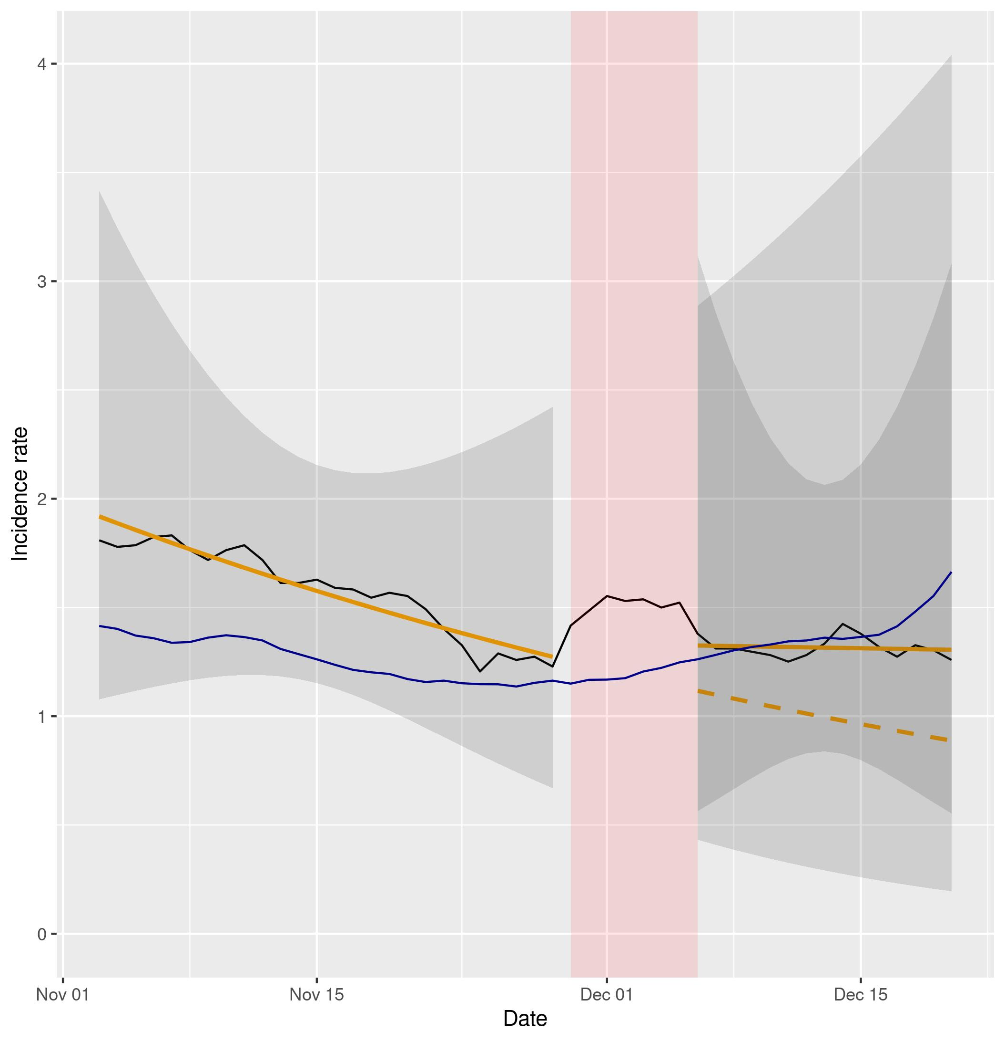
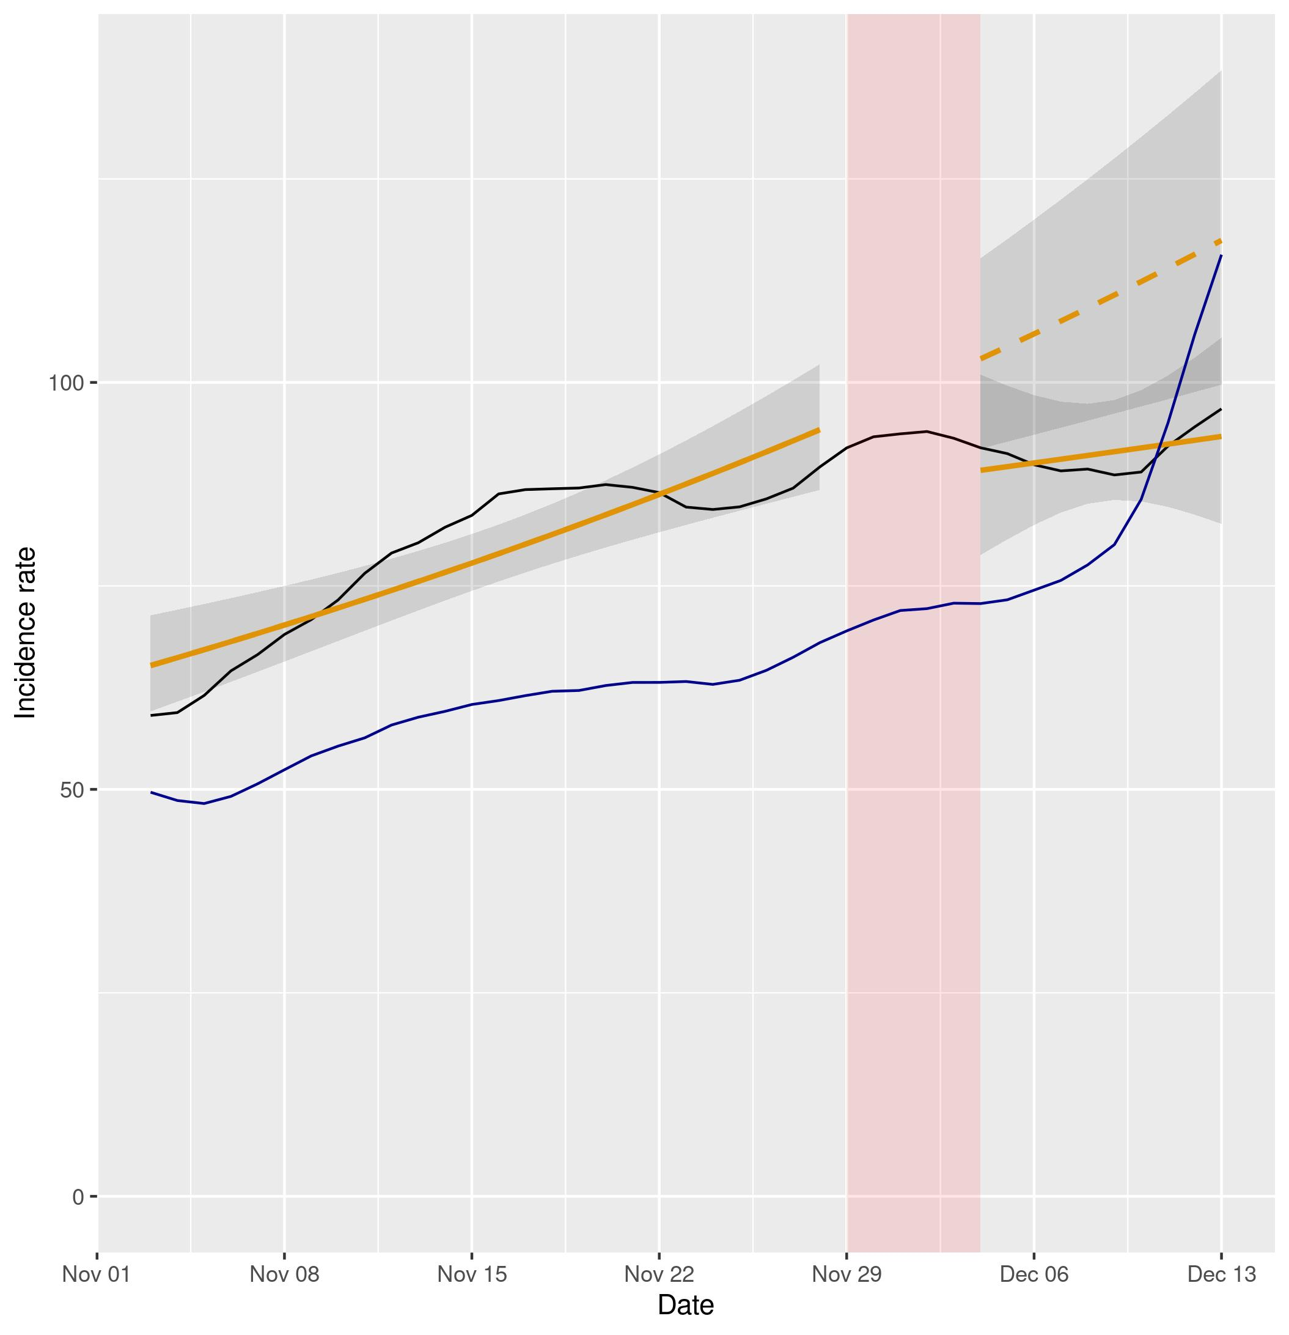

Figure S1a (left) and S1b (right). Representation of NBSR models comparing incidence rates of cases and hospital admissions in Northern Ireland (data in black, model in orange) vs England (data in blue). Dashed lines represent the expected evolution without intervention. The red shadowed area represents the neglected period post-intervention in the model due to the lag between the intervention and its effect and the grey shaded area represents the 95% confidence intervals for the predictions.

Wales
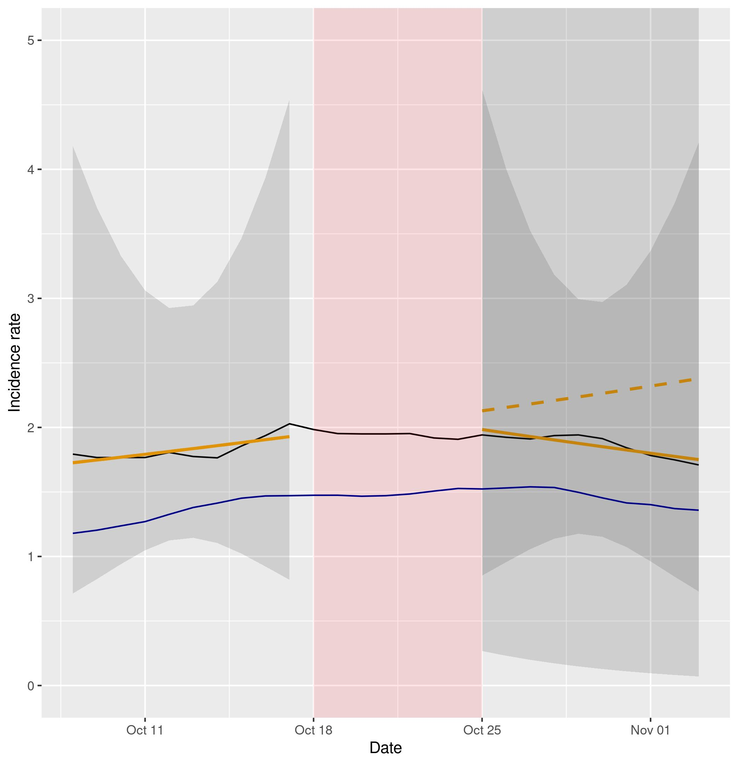
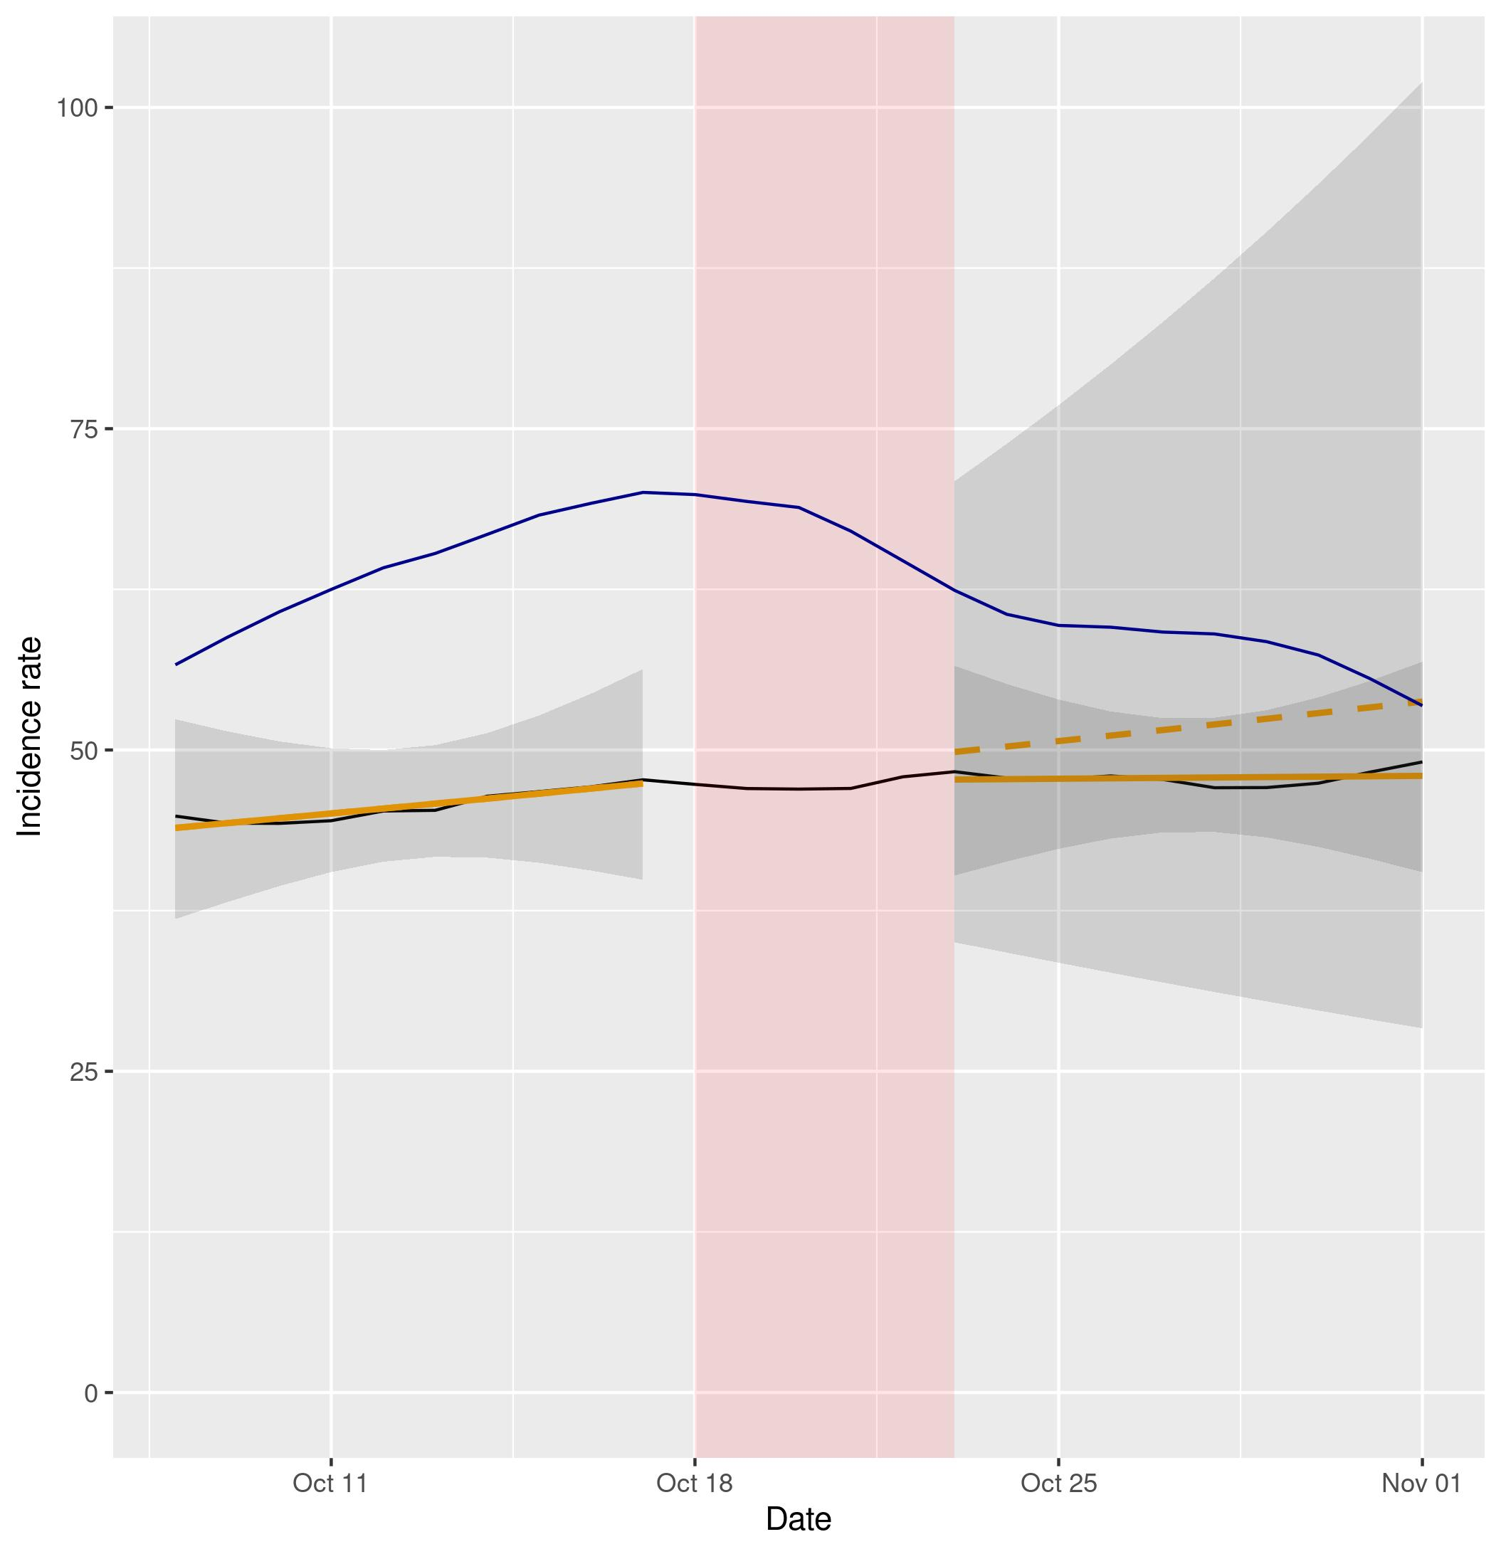

Figure S2a (left) and S2b (right). Representation of NBSR models comparing incidence rates of cases and hospital admissions in Scotland (data in black, model in orange) vs England (data in blue). Dashed lines represent the expected evolution without intervention. The red shadowed area represents the neglected period post-intervention in the model due to the lag between the intervention and its effect and the grey shaded area represents the 95% confidence intervals for the predictions.
Note: In figure 2b the y axis has been cut to make the trends more visible, as the confidence interval for the predictions post-intervention is relatively large.

Scotland
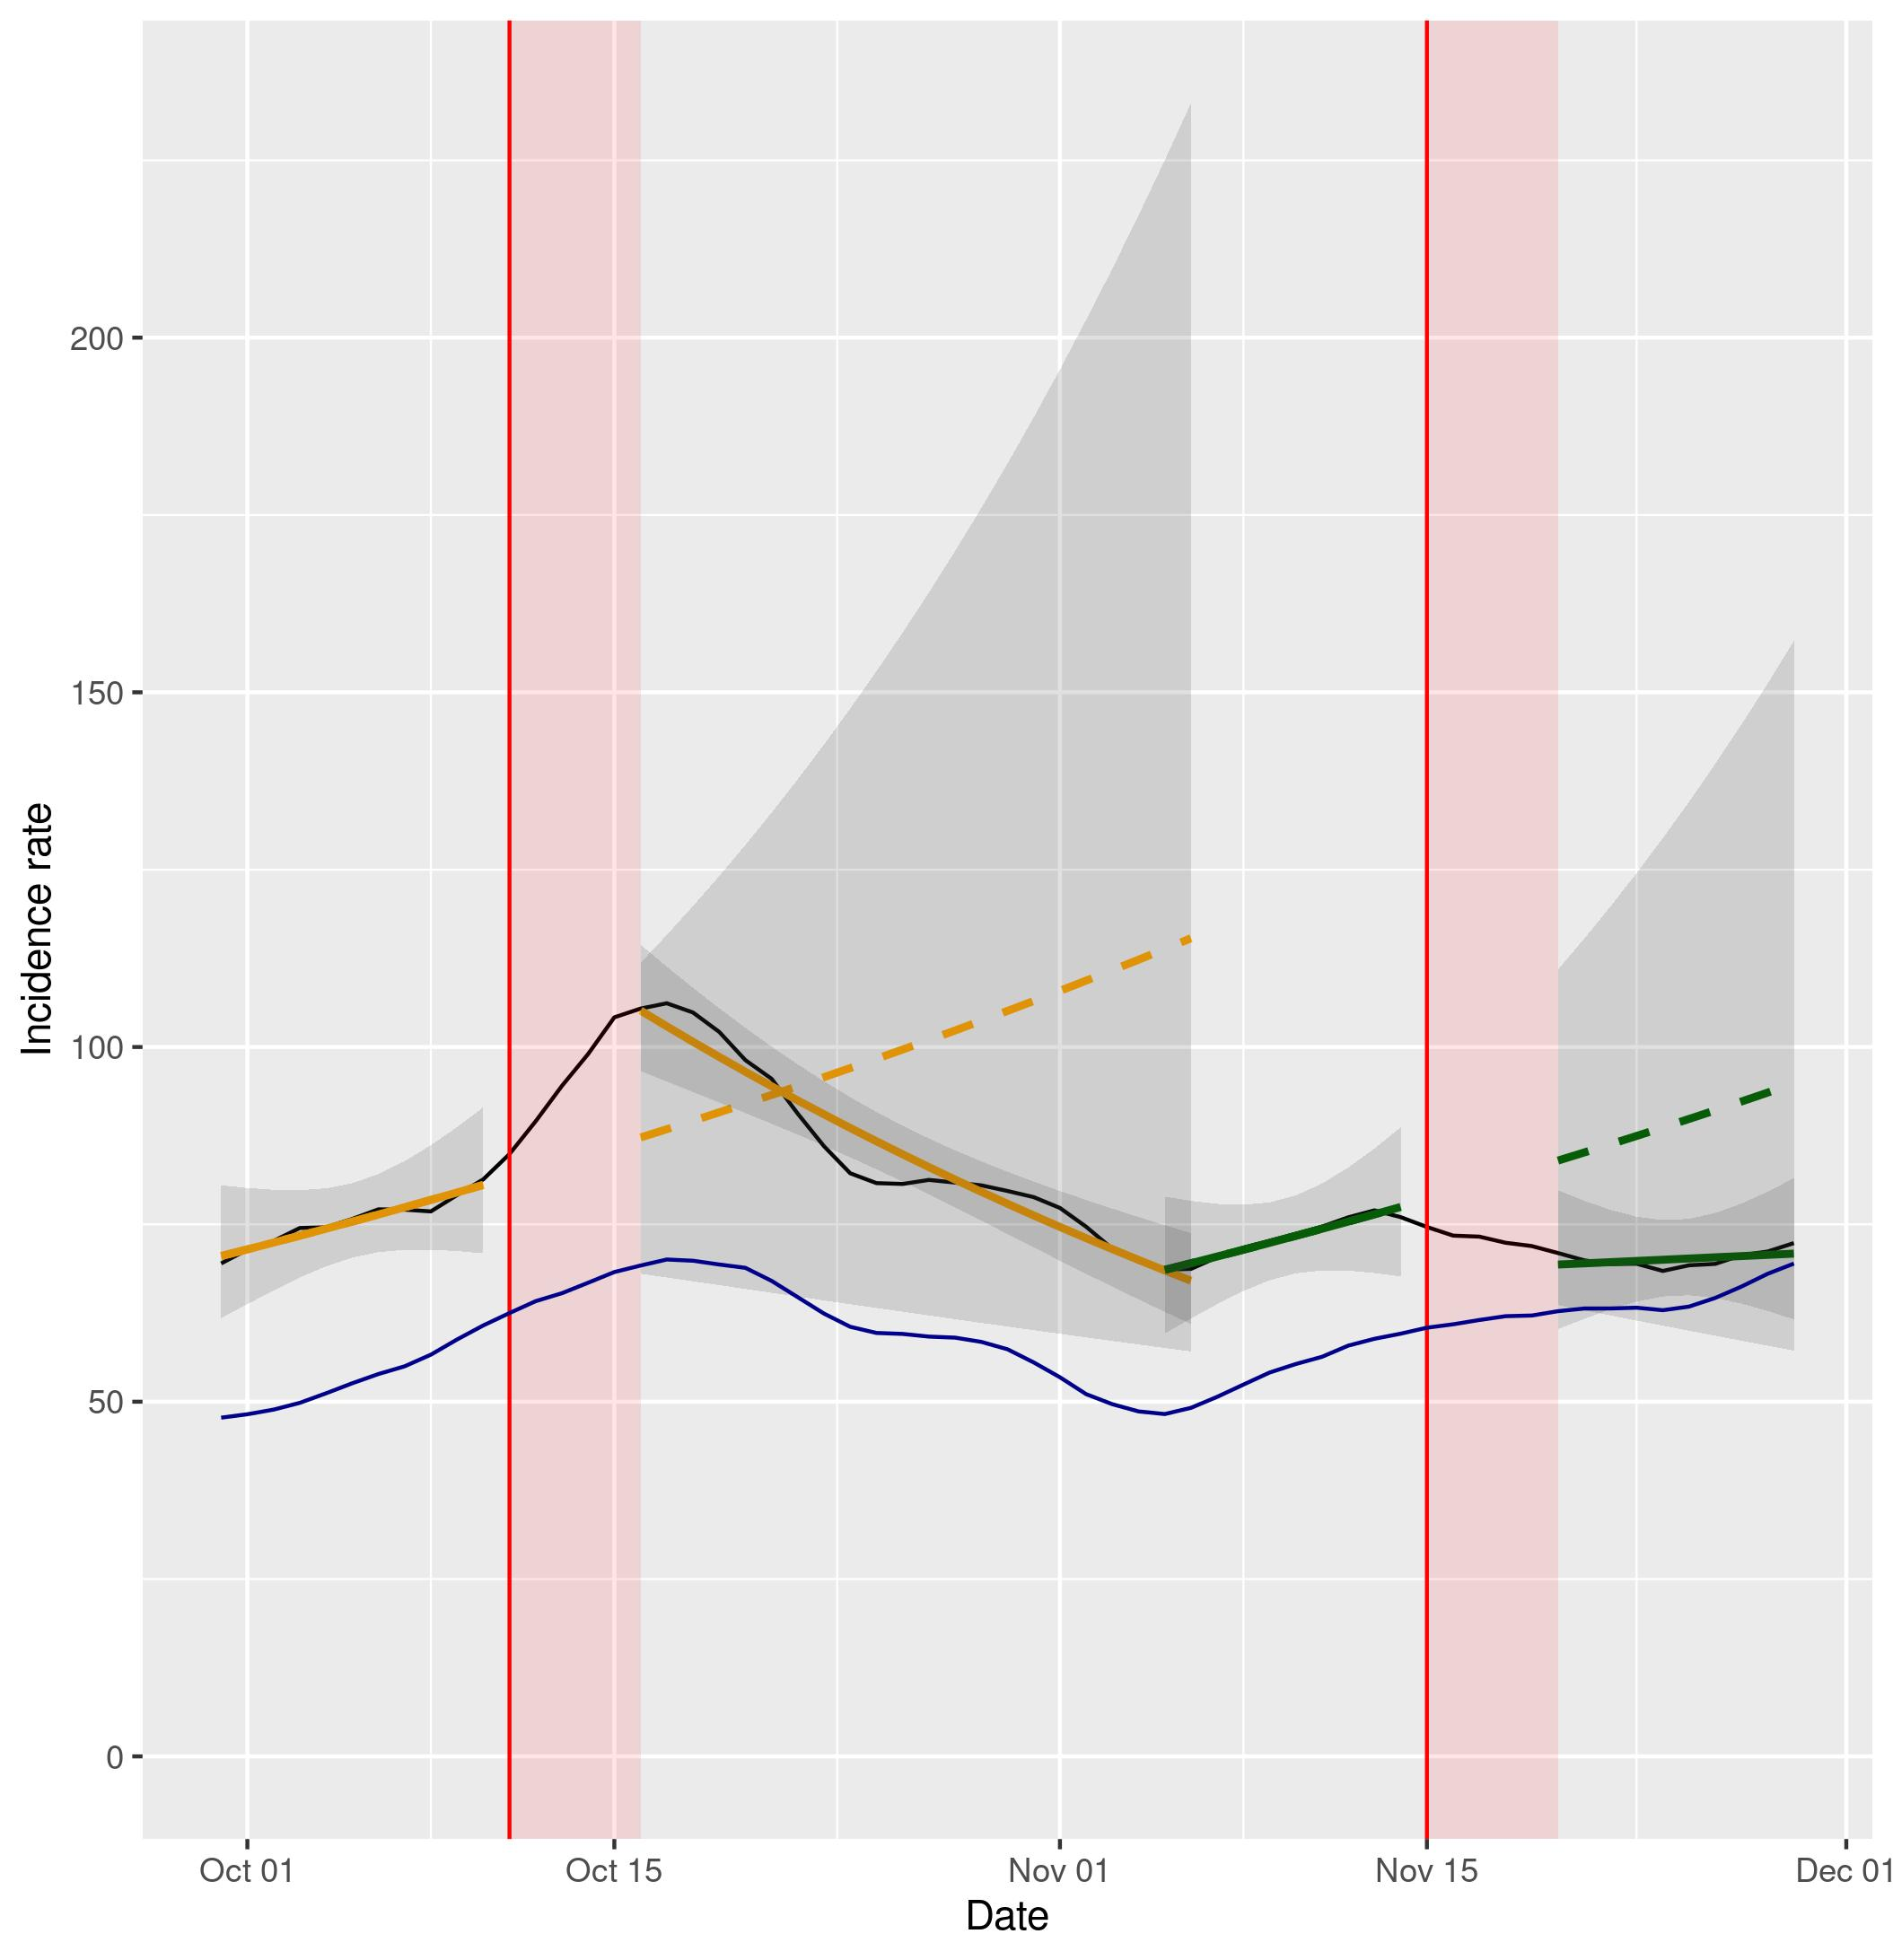
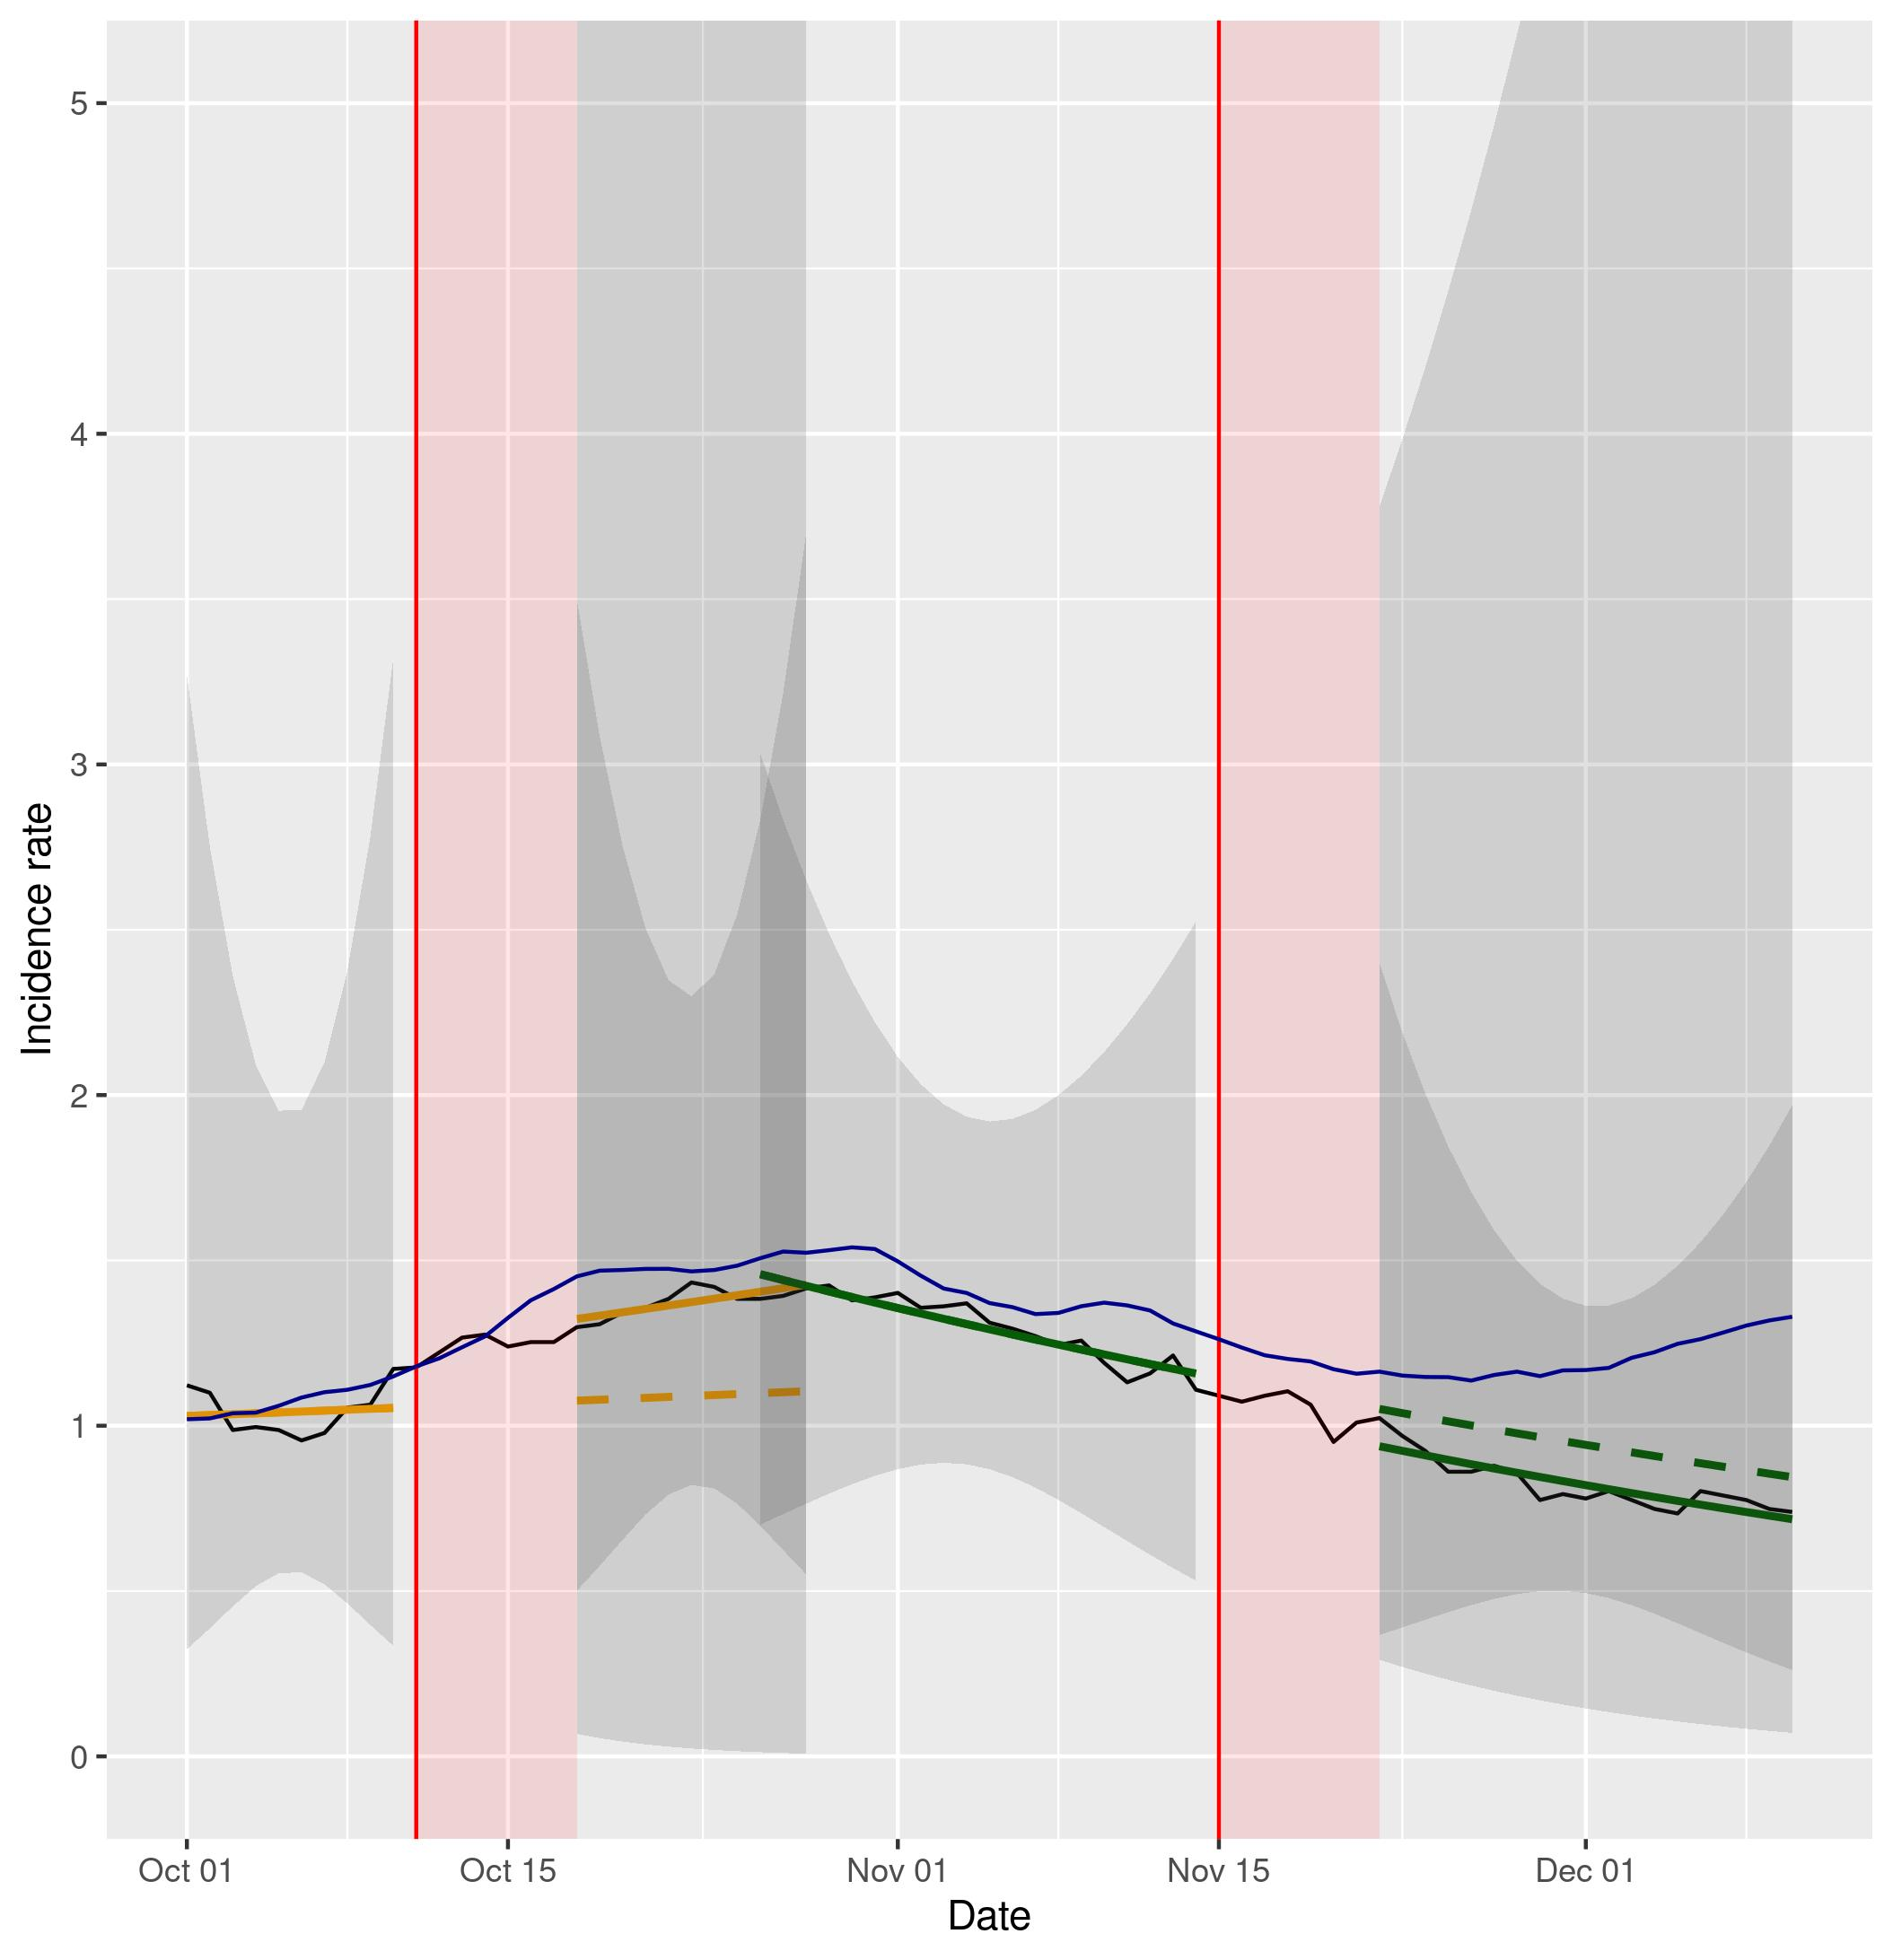

Figure S3a (left) and S3b (right). Representation of NBSR models comparing incidence rates of cases and hospital admissions in Wales (data in black, model in orange and in green) vs England (data in blue). Dashed lines represent the expected evolution without intervention. The red shadowed area represents the neglected period post-intervention in the model due to the lag between the intervention and its effect and the grey shaded area represents the 95% confidence intervals for the predictions.
Note: In figure 3b the y axis has been cut to make the trends more visible, as the confidence interval for the predictions post-intervention is relatively large.

England

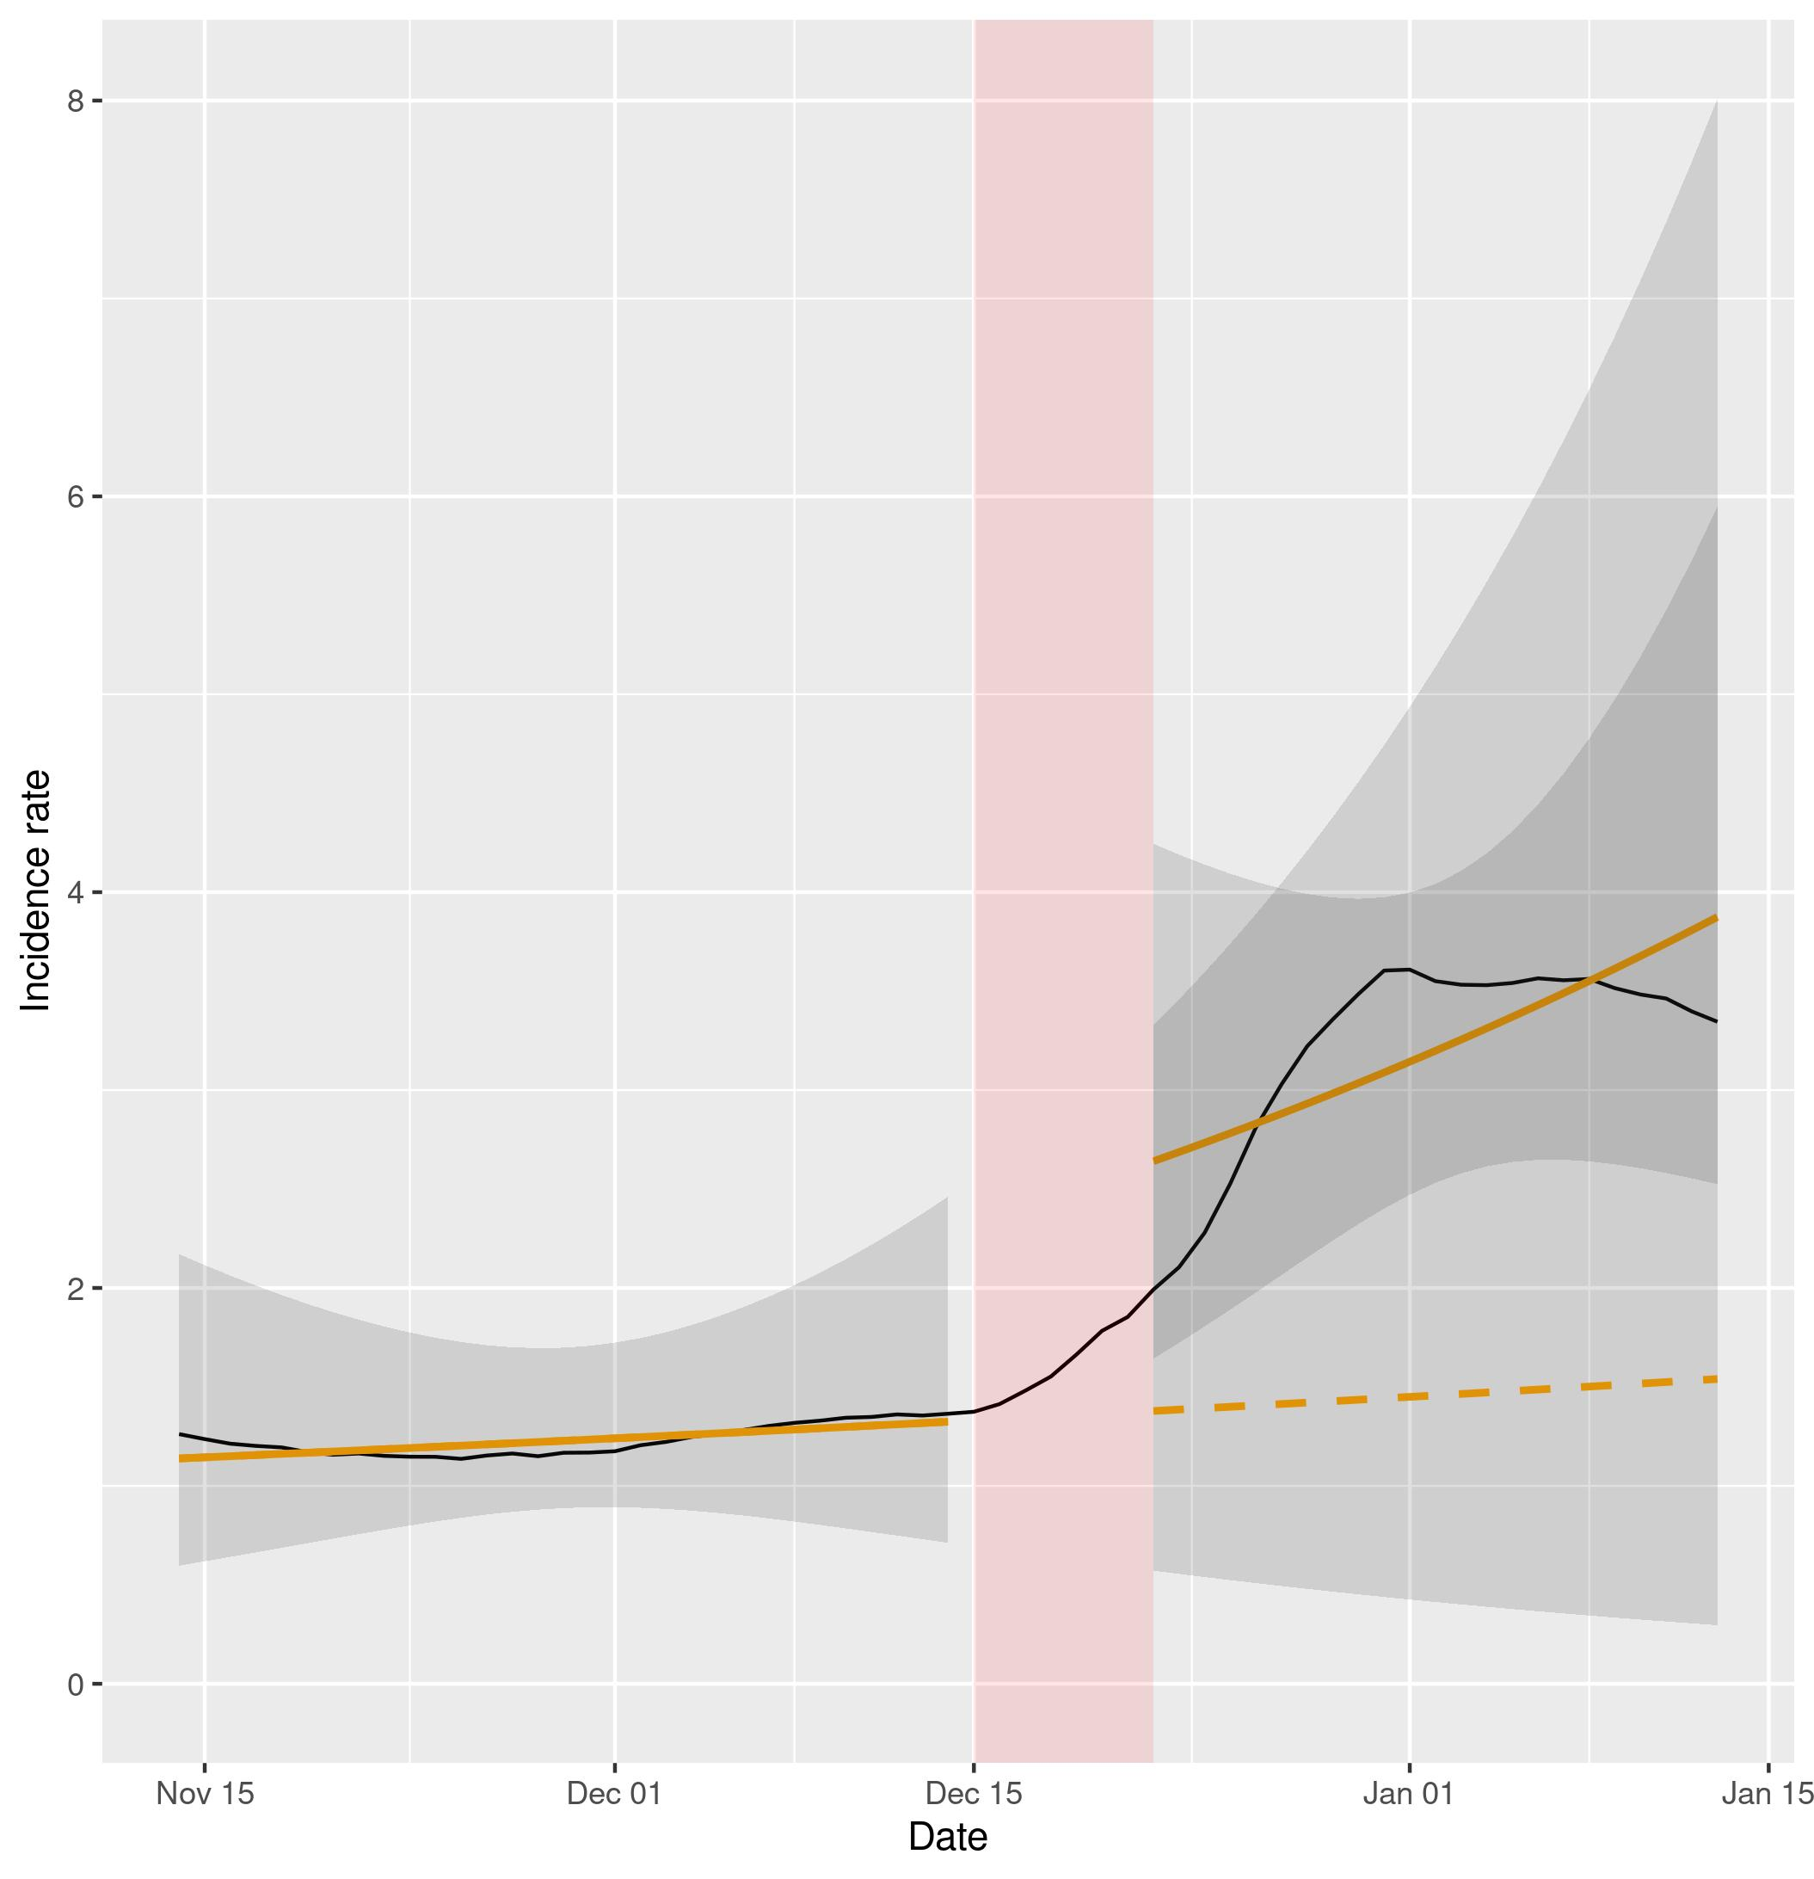
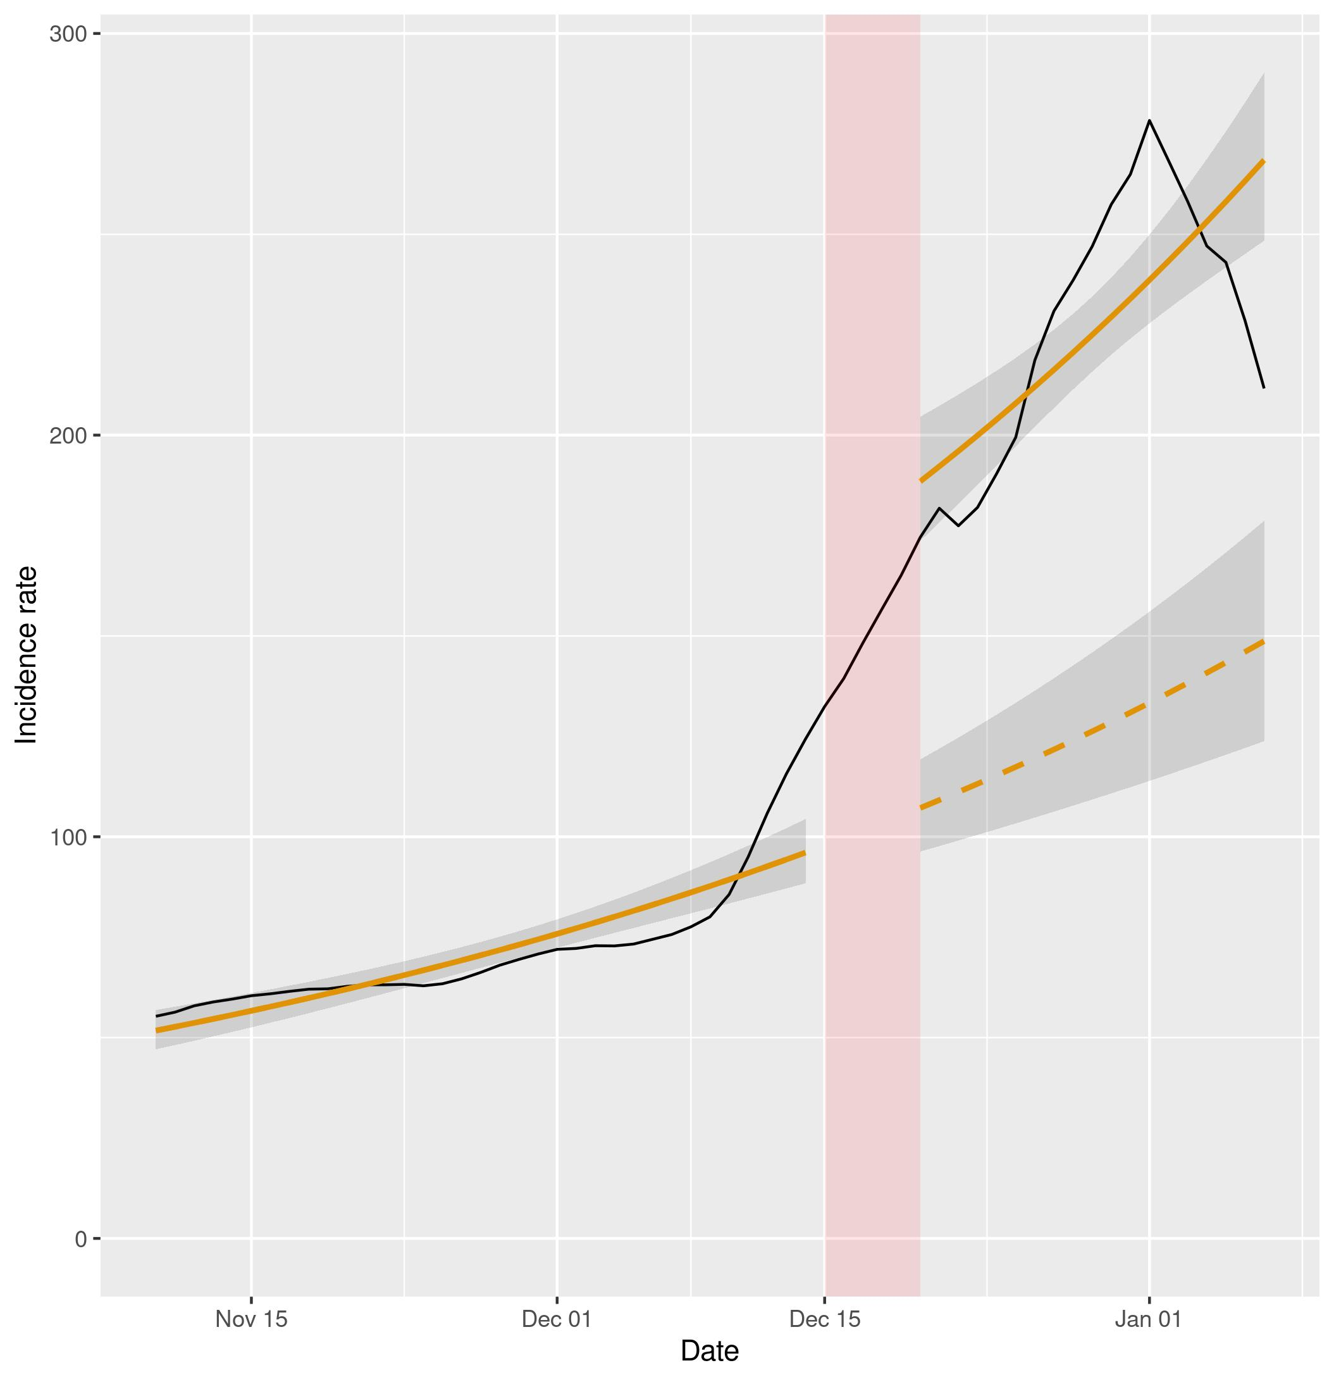

Figure S4a (left) and S4b (right). Representation of NBSR models of the incidence rates of cases and hospital admissions in England (data in black, model in orange). Dashed lines represent the expected evolution without intervention. The red shadowed area represents the neglected period post-intervention in the model due to the lag between the intervention and its effect and the grey shaded area represents the 95% confidence intervals for the predictions.

